Assignment : DNS Lookup Process

Many website URLs we encounter today contain a third-level domain, a second-level domain, and a top-level domain. Each of these levels contains their own name server, which is queried during the DNS lookup process.

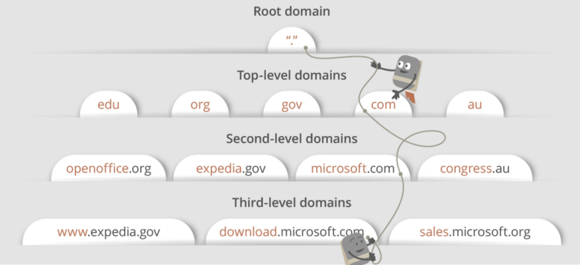

For example: If we give maps.google.com in the browser : first, the DNS resolver will contact the root name server. The root name server will redirect it to the **.com** domain name server. **.com** name server will redirect it to the **google.com** name server.

The **google.com** name server will find the matching IP address for maps.google.com in its DNS records and return it to your DNS resolver, which will send it back to your browser.

